**Linear search Order of Growth**

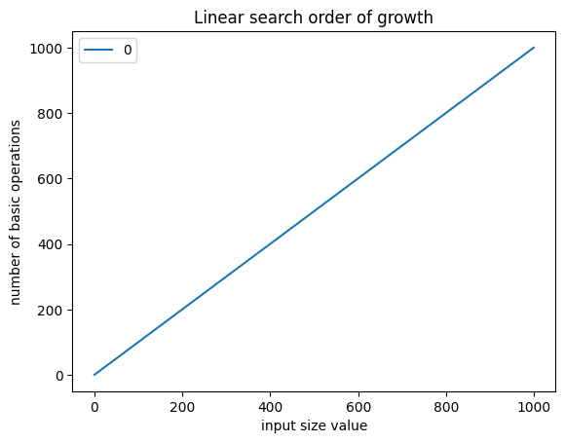

**Tower of Hanoi Order of Growth**

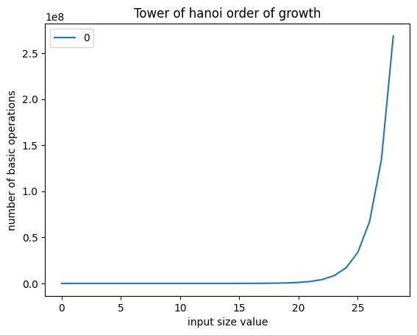

**Bubble sort Time Complexity**

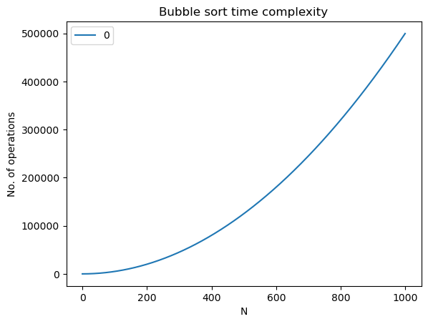

**Bubble sort Time Complexity Table**

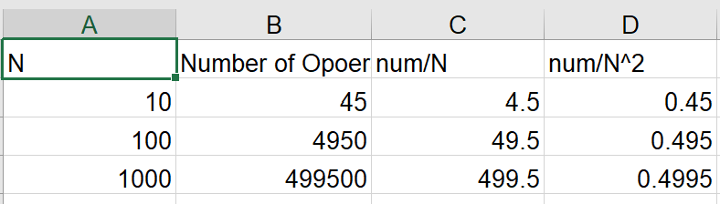

**Merge sort Time Complexity Table**

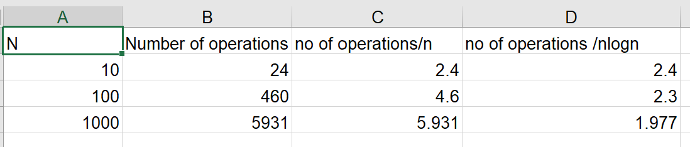

**Quick sort Complexity Table**

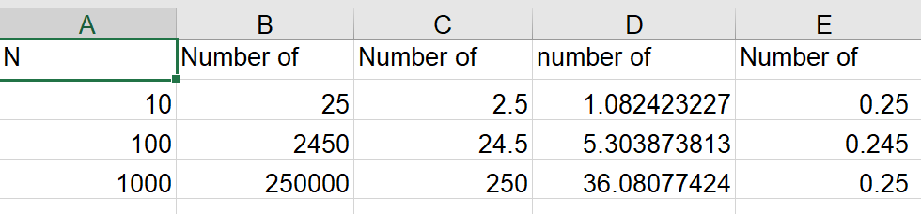

**Quick Sort Graph**

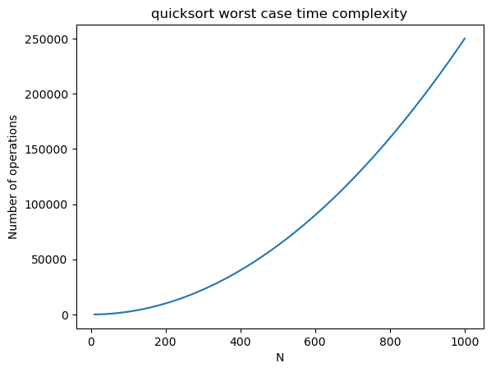

**Selection Sort Table**

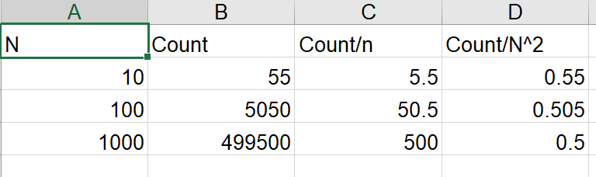

**Selection sort Order of Growth**

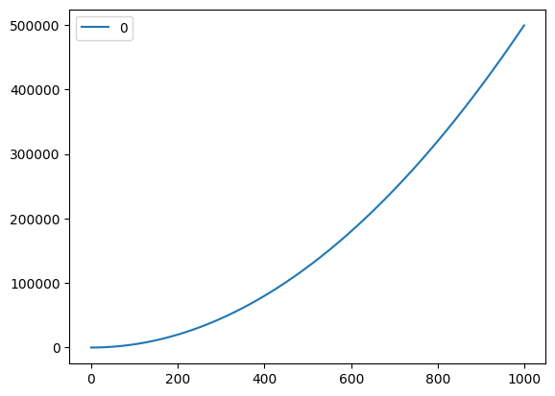

**Linear Binary Search Output**

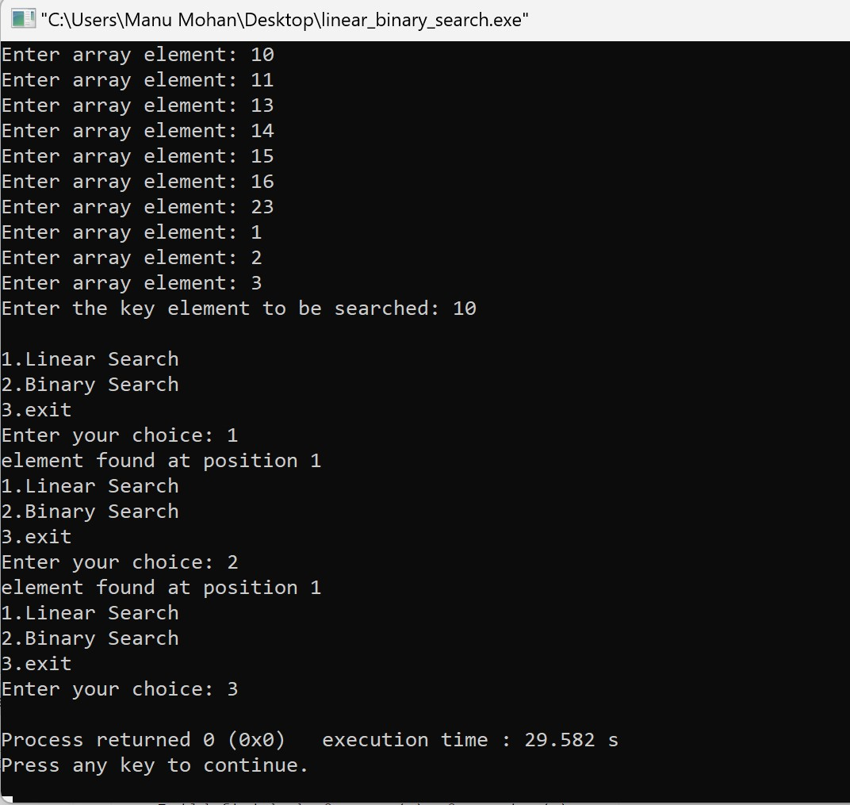

**Factorial Output**

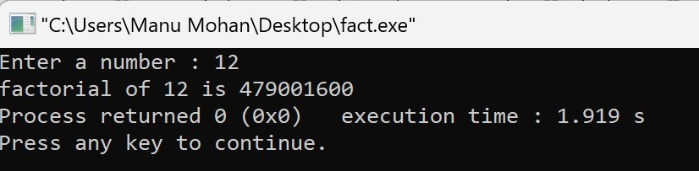

**Fibonacci Output**

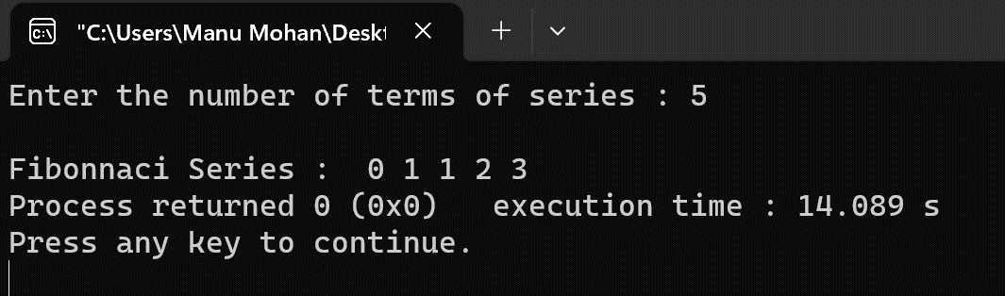

**GCD of 2 Numbers Output**

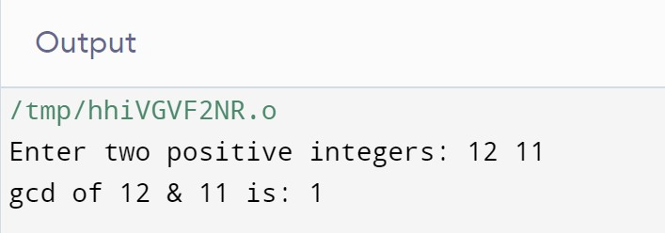

**Krushkal’s Algorithm Output**

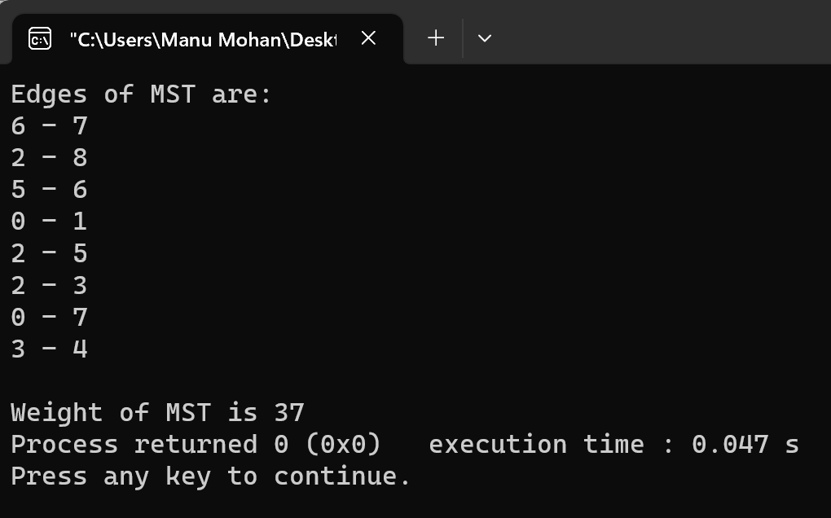

**Prim’s Algorithm Output**

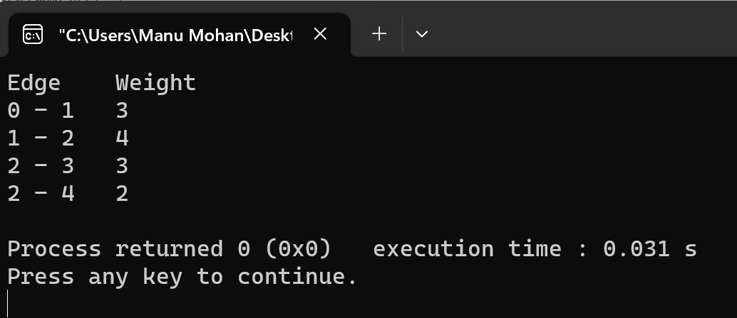

**Digkstra’s Algorithm Output**

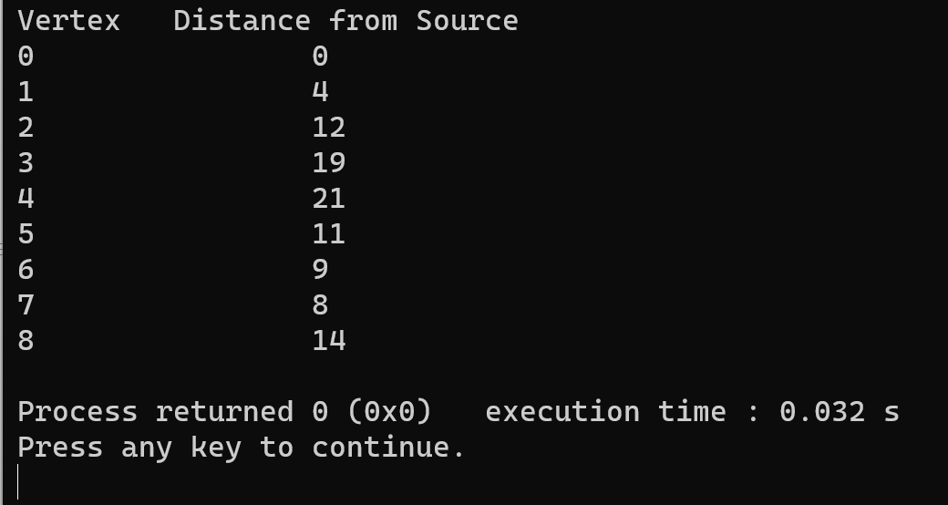

**Quick Sort Output**

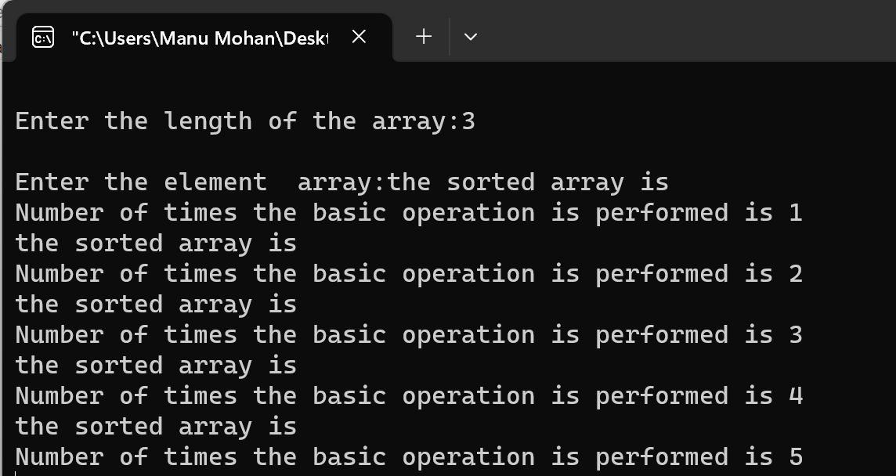

**Merge Sort Output**

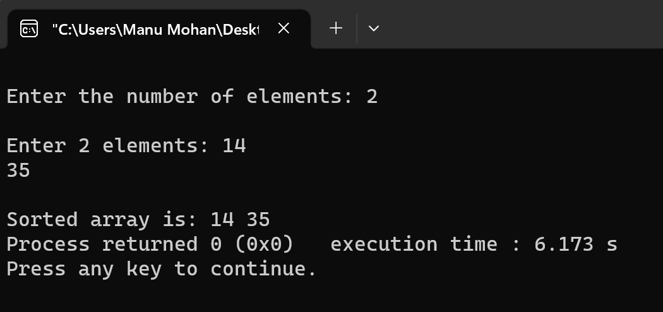

**Selection sort Output**

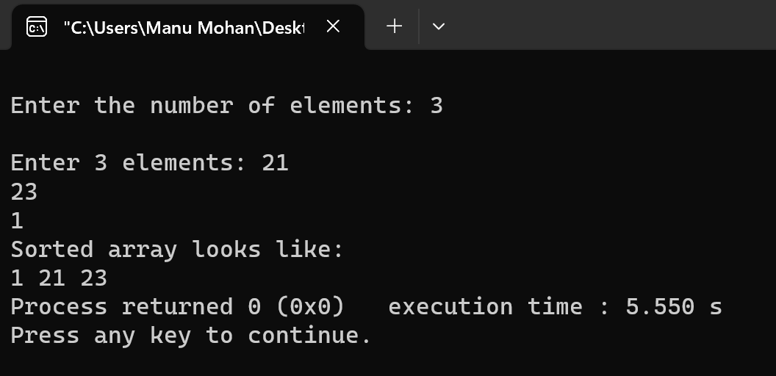

**Dynamic Programming( Binomial Coefficient) Output**

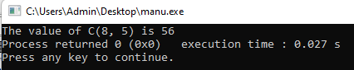

**Dynamic Programming( Knapsack) Output**

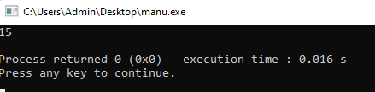

**Floyd Warshal Output**

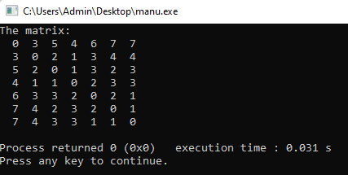

**Heap Sort Output**

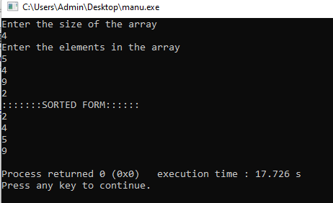

**Horspool Output**

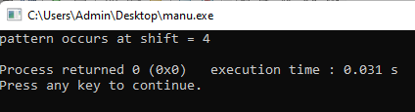

**Sum of Subsets using Backtracking**

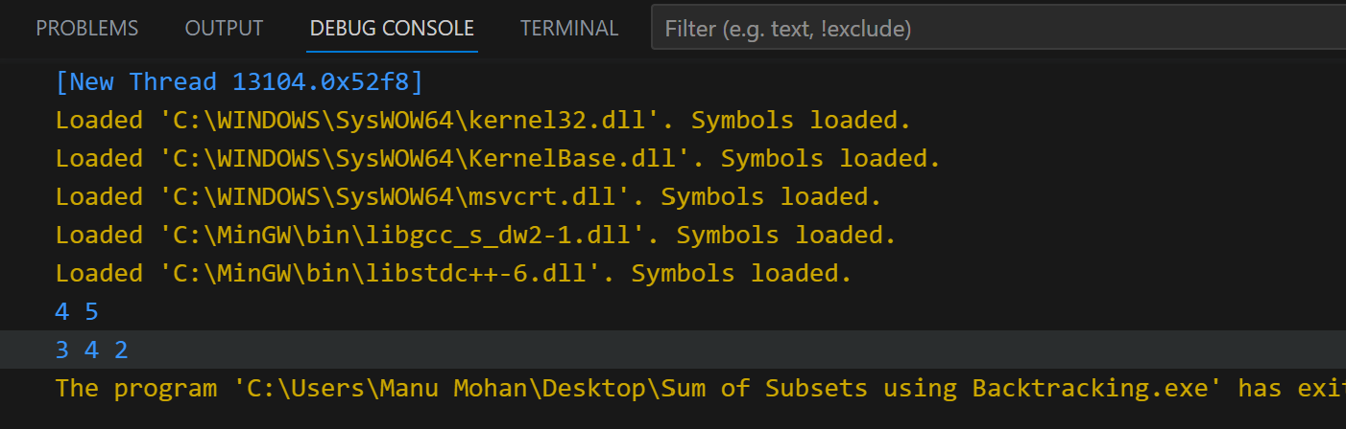

**N Queen’s**

